The Israel Faith Journey

Itinerarie 07- Days 06 Nights!

Day 1 - Nazareth – Cana – Tabor:

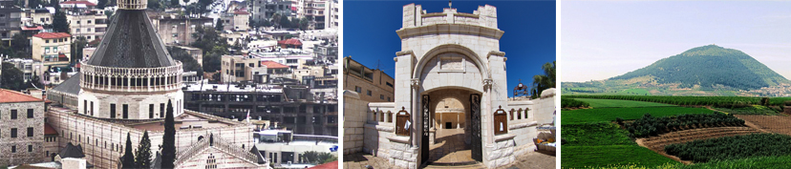
We spend the day in Nazareth, where Jesus lived as a child, growing up amongst the other children of the city, and later working with Joseph who was a carpenter. It is here in the Church of the Annunciation just behind the altar where you can see the grotto where Mary said “yes” to the angel of the Lord. We visit St. Joseph’s carpentry shop and Mary’s well. Then we visit Mt. Precipice the Gospel Trail offers the opportunity to discover the cradle of Christianity by experiencing both physically and spiritually the same biblical landscapes and sites of the Galilee where Jesus and his disciples once walked. The Gospel road is about 60 kilometers, but we will walk about one hour down the mountain. Once we will make our way down we will see a wonderful view of Emek Israel. Then we visit Cana, where Jesus performed his first miracle, changing the water into wine. Then, we travel on to Mt. Tabor, the site of the Transfiguration, the church, built by the Franciscans in the early 20. From there we return to our hotel in Tiberius for dinner and
overnight.

Day 2 - Beatitues – Capernaum – Tabgha:
Today we visit Mount of Beatitudes where Jesus delivered perhaps the most significant sermon ever preached – “The Sermon on The Mount”. Here, we contemplate and reflect through prayer before continuing to Capernaum,
the town where Peter lived and where Jesus based his Galilean ministry. We visit the ruins of the town and gain an understanding of why Jesus focused his ministry here, where ancient Judaism flourished. We will visit the Synagogue where Jesus healed and taught, and Peter’s house. We proceed to Tabgha, the site of the multiplication of the loaves and the fishes; we will also visit the Church of St. Peter’s Primacy, where Jesus appeared after the Resurrection. We enjoy a relaxing boat ride on the lovely Sea of Galilee. Return to the hotel for dinner and overnight

O/n Tiberius – or Nazareth Hotel. (B. L &D).

Day 3 - Travel to Gerusalemme:

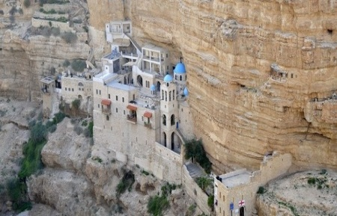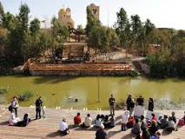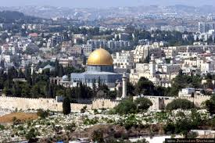
Check out from the hotel and depart for our touring day. Driving south along the Jordan Valley to Our first stop, from there we proceed to Jericho, we stop in Jericho, the world’s oldest city. From the excavated Tel atop the ruins of ancient Jericho, we view the lush green Jordan Valley, Elisha’s spring and Qarantal, the Mount of Temptation. Next, we drive to Qas’ar el Yahooed,

the baptism site, the site where Jesus' baptism by John. Our day will continue with a drive to Jerusalem through the Jordan Valley’s stunning landscape. We will stop at Mt. Scopus upon arrival in Jerusalem for a magnificent view of the city and a brief Explanation about the capital in the past and future. Then drive to the hotel for check in and overnight. Overnight in Jerusalem.
O/n Jerusalem – or Bethlehem. (B -L & D).

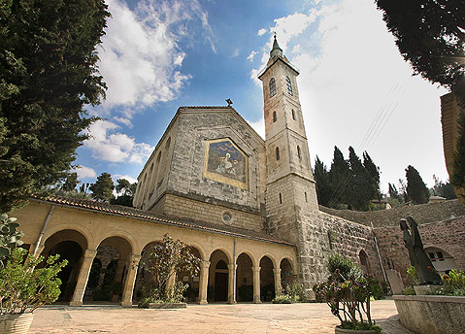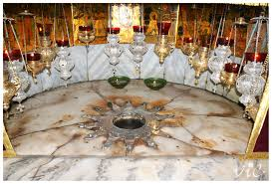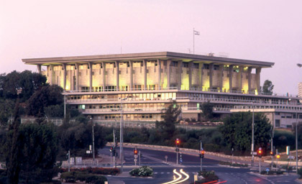

Day 4 - Ein Karem, Bethlehem:
After breakfast in Hotel, we visit Ein Karem, birthplace of John the Baptist and Church of the Visitation where Mary uttered the words of the Magnificat. From there, we proceed to Bethlehem City for tradition Lunch. After Lunch we proceed to visit the cave in Shepherd’s Field and view the Fields of Boaz. We will stop for shopping in Bethlehem City, then return to the hotel for dinner, and overnight.
O/n Jerusalem – Grand Court Hotel. (B. L & D).

Day 5 - Mt. Zion:

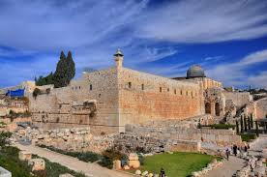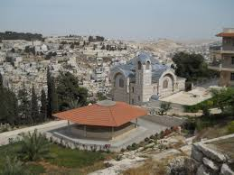

After Breakfast, we proceed to visit Mount Zion, the Upper Room, and Dormition Abbey. In addition, visit St. Peter in Galicantu.
O/n Jerusalem – or Bethlehem (B. L & D).

Day 6 - Gerusalemme Old City:
Gethsemane, Mt. of Olivese,

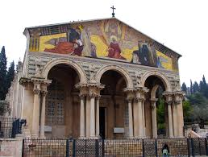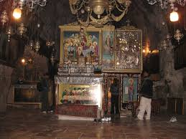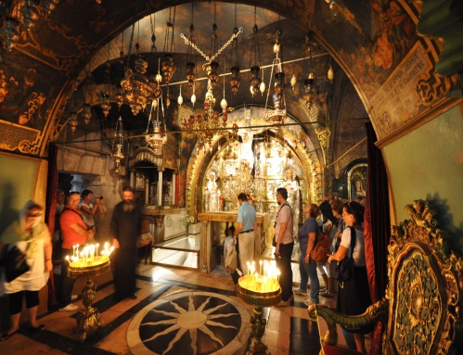
This morning, we follow the Via Dolorosa (Stations of the Cross) through the old city to the Church of the Holy Sepulcher, where we pray on top the Rock of Calvary, inside the Lord’s tomb. We will visit also Pilate’s Judgment Hall, the Chapel of Flagellation, Lithotrites, and the Arch of Ecce Homo (“Behold the Man”) and the Convent of the Sisters of Zion. Continue to the Mount of Olives for a panoramic view of Jerusalem. We visit the Church of Pater Noster and the Chapel of Ascension and then we walk down the hill to Dominus Flevit Chapel, where Jesus wept over Jerusalem. We proceed to the Garden of Gethsemane and the Church of All Nations where Jesus endured his Agony, visit
Mary’s Tomb. Return to the hotel, Dinner and overnight. O/n Jerusalem - Grand Court. (B. L & D).

Day 7 - Departure:
After breakfast, check out from hotel and transfer to Ben Gurion Airport for departure.
The Terms and contingencies/Policies of this Holy Lands Tour operation2018
Cancellation Policy:
All cancellations must be sent to Aeropax Travels, Inc. in writing by the person with passport details who made the reservation and are effective received by the Aeropax Travels, Inc.
No refunds for cancellations received after tour departure, during the tour, or any unused portion of the tour.
Minimum Size of Group is 25 Passengers, Maximum 54 or more,
The Rate worked out the current availability of the Air fare (Subject to change at any time without prior notice of the Airlines)
Each Airport we need minimum 20 or More Passengers as a Group.
Also, all other state individual passengers can be joining in this group from New York- (JFK) Airport. (With their own expense)
Policy of Travel Insurance: Optional and we are strongly recommended, available Allianz Global Travel Insurance and choose the plan which you may require as per your
date of birth. For get a better quote Please buy it at least 21 Days prior to departure date.
use the Agent Accam # F204871. Assistance available at Aeropax Travels, up on request. All pilgrim has to be signed a Travel Insurance responsible waiver form prior to their departure at the Airport.
The Aeropax Travels, Inc. Or its associate agents in the USA, or in abroad are not responsible for any change in medical condition during the tour. Or you need waiver of travel insurance you have to fill up and
signed waiver from and submit to the Aeropax Travels, Inc. prior to the tour departure.
Luggage: Is the responsibility of the Passenger Any /all damage or loss must be reported at time of incident and documented in writing by local authorities for submission to the insurance company.
We arrange all Christian’s denominations Tours are available up on Group Request!
This pilgrim tours are open for all Church denominations. Each Airport we need minimum size of group 30 or More adults Passengers as a group. also, all other state individual passengers can be joining in this group from New York- (JFK) Airport with their own expense.
Price & Accommodation:
All prices are based in USD on double occupancy. A Single Pilgrim who wants to join this group they have to find their friends or siblings as their roommate or they can stay at a single supplementary everyday with extra cost $500.0 to be added to the actual tour cost.
Documentations:
Passport &Visas: All Passengers must be having minimum 6 Months or more validity of their Passports with effect while return date of the trip.
We will take care of all Visas and Exit Permits for US and Canadian Citizens.
US Green Card Holders:
All US Green card holders must obtain only an Israel tourist visa apply in persons by their resident’s state jurisdiction’s consulates or Embassies. We will issue all the supporting documents. Aeropax will

take care of all other Visas and Exit permits before departure. There are no immunizations or Vaccinations are required.
Payment & Deposit:
For secure a group special air fare a deposit of $500 is required, Cash, Personnel Checks or Bank casher check and Registration form with a color copy of Passport each person on or before May 31st, 2019.
All Payments must be Payable in favor of “Aeropax Travels, Inc.”
Personnel Cheques or Cahier checks are accepted.
Final Payment: Due On or before 45 days prior to departure date.
Deviation: Any kind of changes in the program is not permitted.
Airlines: Fares and schedules flights are subject to change without Prior notice. It is recommended all passengers must report at the airport 03
Hours prior to departure.
Cancellation Policy Land Portion:
Prior to departure : Cancellation Penalty.
After deposit Paid : $200 Nonrefundable per person
60 days prior to departure :75 % Nonrefundable
59 days prior to departure : 100% Nonrefundable

Cancellation Penalties for Air Portion:
Depending on the Airline regulations. Penalties may be equal to the cost of the ticket.
Responsibility:
The Aeropax Travels, Inc. and or its Agents and their representatives abroad, Act only: -
As agents for the tour participants in making arrangements for Hotels, Transportations, Touring, Restaurants or any other services in connection with the Itinerary. They will exercise reasonable care in making such arrangements. However, they do not assume.
Typing Error & Marketing Policy:
The Aeropax Travels, Inc. Or its trade associates in USA and in Abroad
Is not responsible for any typographical or Printing errors, Omissions or
Unintentional misrepresentations made on other than the contents of Aeropax Published itinerary. Please review carefully the terms and contingencies prior to register your trip.
Any liability whatsoever for any injury, damage, Loss, accident, delay or irregularity to Person or property because of any act or default of any hotel, carrier, Restaurant, Company, or person rendering any of the services included in the tours. The tickets, coupons, tariffs, rules
Or contracts currently in use in by any carrier, hotel, Restaurants or other contractor rendering services shall constitute the sole contract between such contractor and tour participants.
If there is any sort of disorder may incur in this tour itinerary due to late arrival time or weather conditions, we will be completing that before ends the tour days.
We will give you the finest tour and the best spiritual experience in the Holy land, Palestine, Egypt and Jordan
The Tour cost $2050/- Includes: (Only if Register with Airline Deposit $500.0 On Or before December 21st,2018.)
Round Trip Air tickets,
Meeting assistance throughout Arrival and Departure
Transportation by Modern A/C Vehicle
Portage at the Hotels
Private English-Speaking licensed guide as per Itinerary
Pilgrimage Certificate per person
3* and 4* Category Hotel Accommodations
Buffet Breakfast and Buffet Dinner Every day
BBQ Lunch at sightseen Restaurants
St. Peter’s Fish Lunch
Boat ride pass in Sea of Galilee,
The Israel Visa fees, Border Tax
All entrance fee as per the Itinerary
The US Green Holders apply in person at their Residence state jurisdiction to Obtain only the Israel Visa we will issue all other supporting- documents.
1 Bottle of mineral water every day.
Tour cost Excludes: -
Drinks with Meals.
Personal Expenses
All kinds of Insurance and Tips.
Anything else not mentioned in the Itinerary.
Tipping $5 everyday PP $3 for Tour Guide and $2 for Driver
Things remember to carry for this group:
220 Volts Universal Power Convertor, for charging mobile and Camera
Light Jackets with hooded, Swimming suite or any other dress for floating in dead Sea which your like.
Medications if any, A pair of most comfortable walking Sneaker and slipper
Other casual dresses which you like,
A Light Jacket with hood.

Baggage Policy:
01 PC/ 50 Pounds Per Passenger
And 01 Cabin Baggage 10 Pounds. PP
Tour Operated & Led by:
Aropax Travels, Inc.
9408 Evans St,
Philadelphia, PA19115
George J. Panackal, DIATM
(Ambassador of Goodwill,
for Israel Ministry of Tourism, USA)
President & CEO - Aeropax Travels, Inc.
Notary Public, State of Pennsylvania.
PH: HO - (855) 237-6729/ 215-600-3520/ Cell: 267-679-4496
Web: aeropaxholidays.com

